Commands used:
Step 1: Identify Live Hosts
Command used:
netdiscover -r 192.168.26.0/24
screenshot:
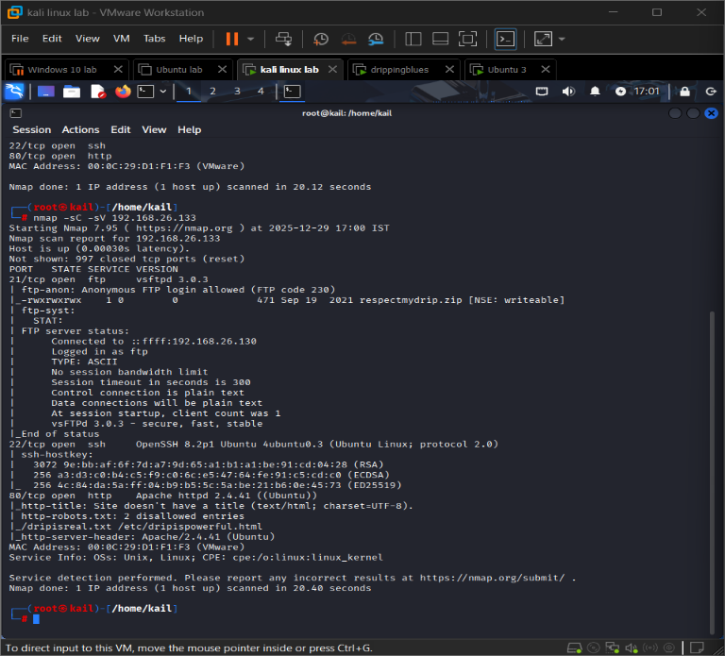
This command is used to identify all active devices in the local network. It helps find the target machine’s IP address before starting any attack.
Step 2: Scan Open Ports:
Command used:
nmap -p- 192.168.26.133
Screenshot:
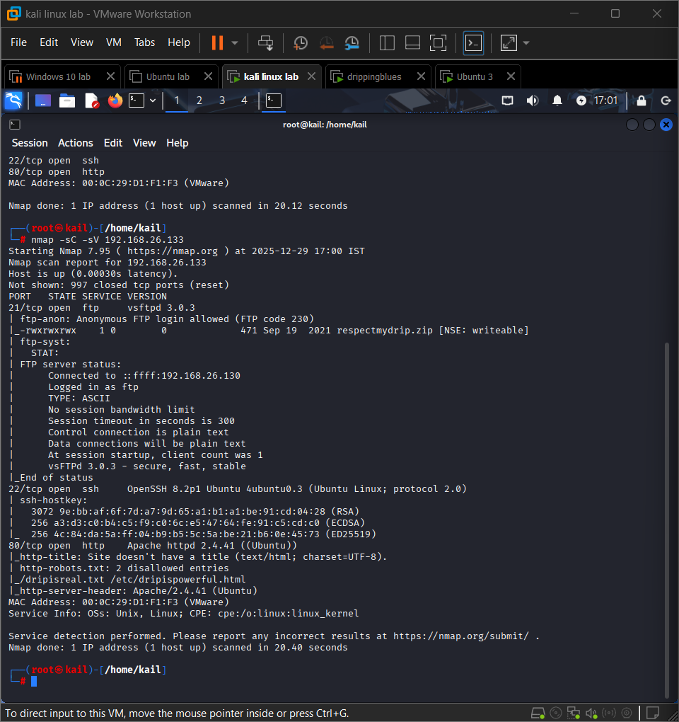
This command scans all 65,535 TCP ports to identify which services are running on the target system.
Step 3: Connect to FTP Using Anonymous Login
Command used:
ftp 192.168.26.133
Screenshot:
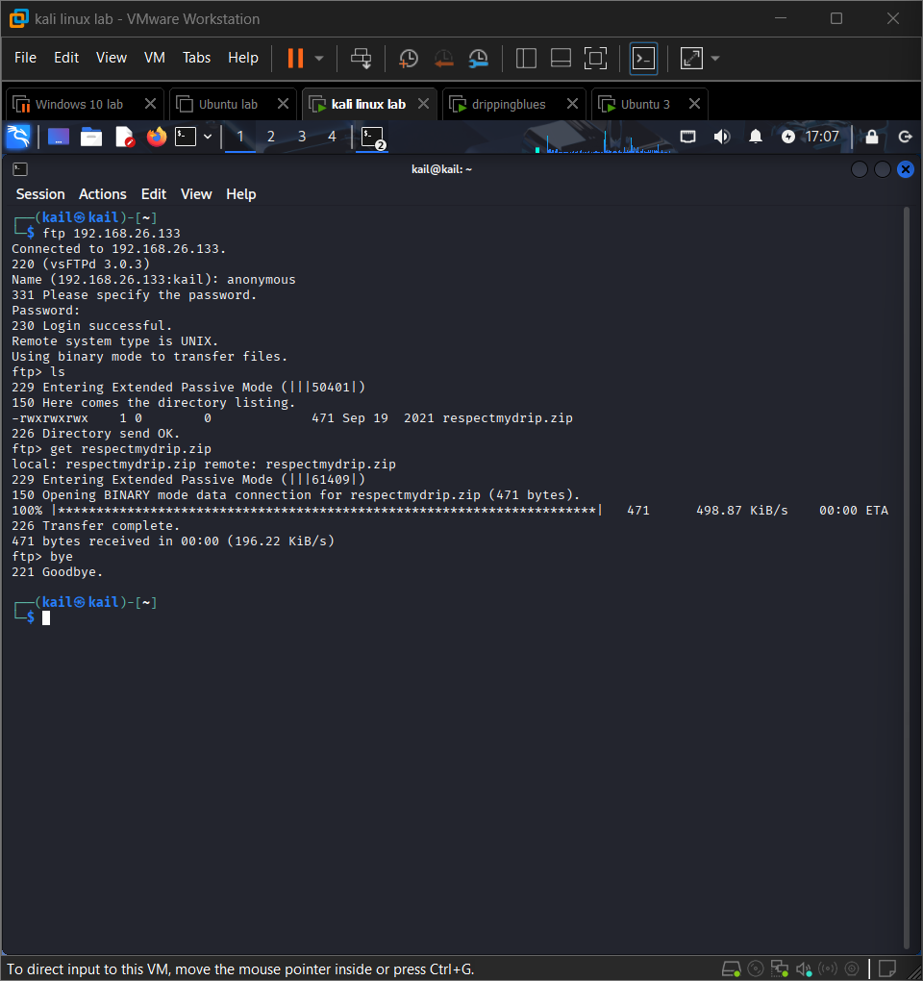
The FTP service allows anonymous login, which means files can be accessed without authentication. This is a security weakness.
Step 4: Download ZIP File
Command used:
get respectmydrip.zip
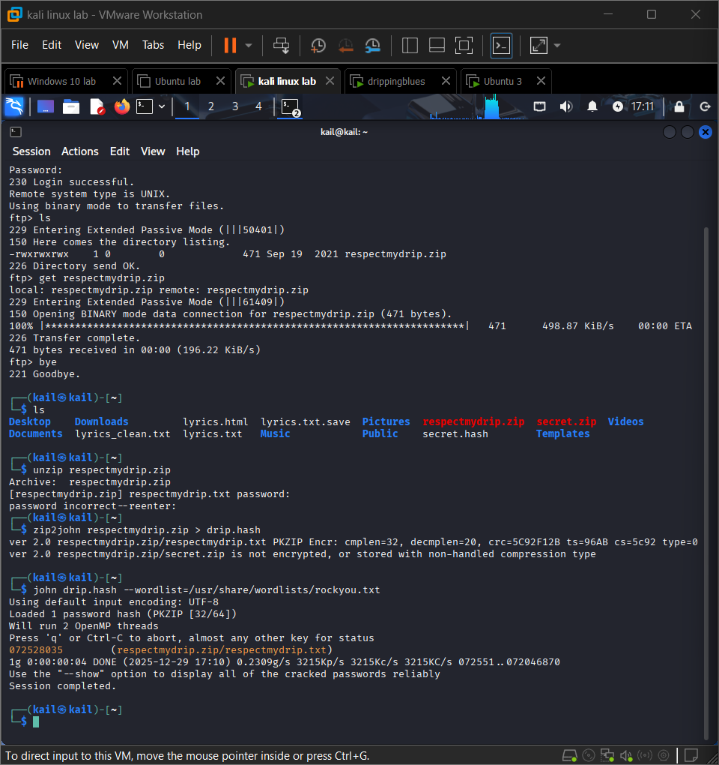
Screenshot:
This command downloads the ZIP file from the target system to the attacker machine for further analysis.

Step 5: Extract ZIP Hash
Command Used:
zip2john respectmydrip.zip > drip.hash
screenshot:
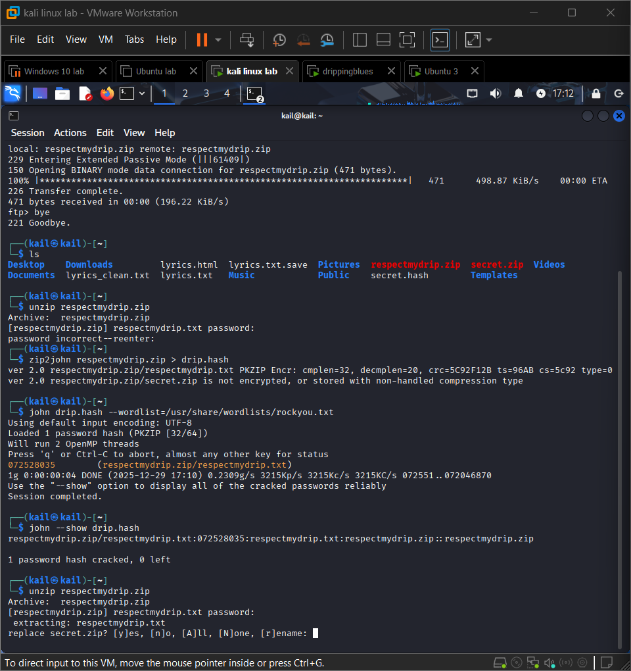
This command converts the ZIP file password into a hash format that can be cracked using password-cracking tools.

Step 6: Crack ZIP Password
Command Used:
john drip.hash --wordlist=/usr/share/wordlists/rockyou.txt
Screenshot:
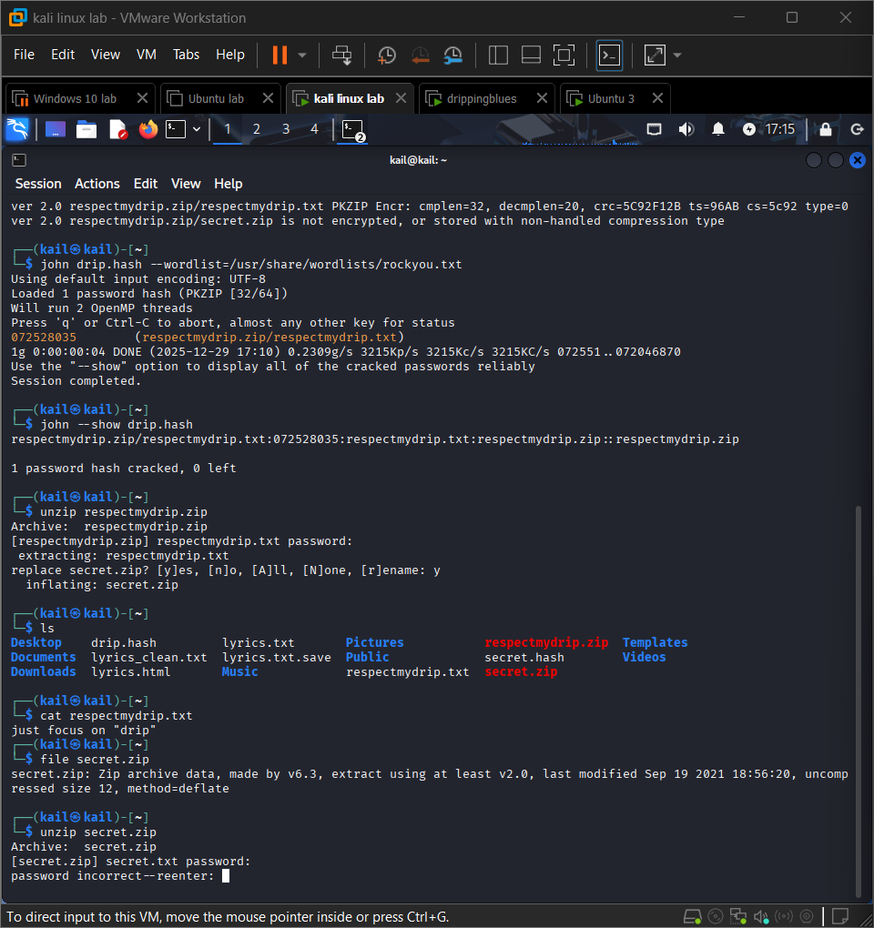
This command performs a dictionary attack using a common wordlist to recover the ZIP file password.

Step 7: Extract and Crack Second ZIP File
Commands Used:
zip2john secret.zip > secret.hash
john secret.hash --wordlist=/usr/share/wordlists/rockyou.txt
Screenshot:
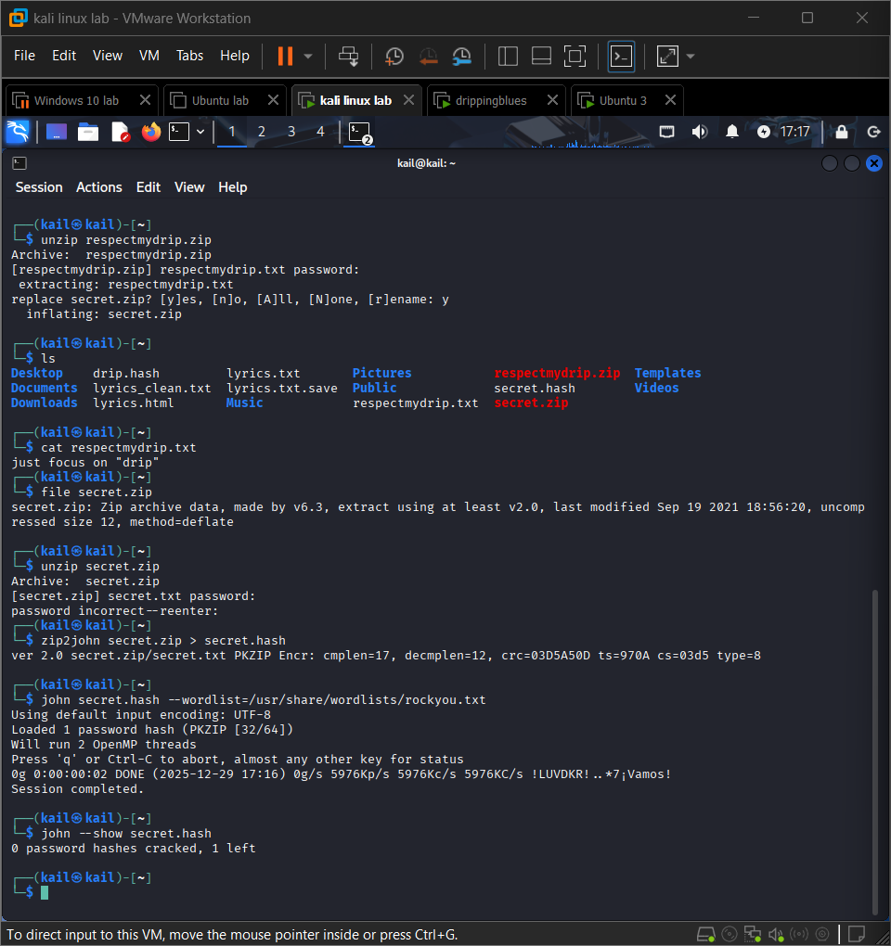
This step cracks the password of the second ZIP file found inside the first ZIP.
Step 8: Final Verification
Command used:
john --show secret.hash
screenshot:
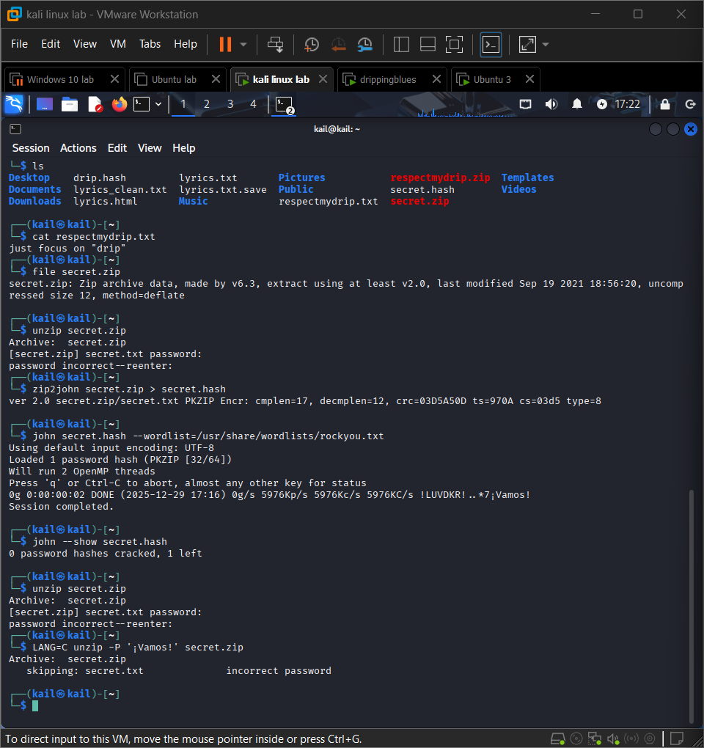
This command displays the successfully cracked password, confirming task completion.

